#
# 20190918
# Dashboards about communigate.
# I don’t know, how to use it with profit, but anyway - it exists...
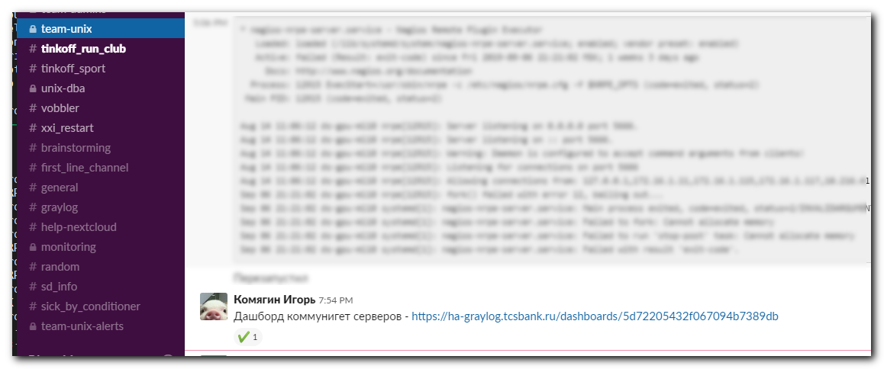

https://ha-graylog.tcsbank.ru/dashboards/5d72205432f067094b7389db

